Preface

This system belongs to the operational management system.
This system was proposed and drafted by the Ministry of Science and Technology Innovation.
This system is interpreted by the Ministry of Science and Technology Innovation.

Management Procedure for Tooling Verification

1 Scope

This document stipulates the process of verifying the capability of tooling to meet product manufacturing or assembly requirements after the acceptance of process equipment and before its use in production, as well as the process of collecting statistical data on tooling performance after it is put into production
This document is formulated in accordance with GLG1407 Tooling Management Rules.

2 Reference Documents

None

3 Form

3.1 Prescribed Form
FM1407-80 Tooling verification checklist
3.2 Referenced Form
None

4 Terms and Definitions

None

5 Institutions and Responsibilities

5.1 Science and Technology Innovation Department
The Process and Equipment Office of the Science and Technology Innovation Department is responsible for organizing the tooling manufacturing units to rework the problems found during the tooling verification process;
5.2 Tooling usage unit
The unit using the tooling is responsible for verifying the tooling used by itself.

6 Regulations

6.1 Compliance Management Requirements
none
6.2 Risk Management Requirements
none
6.3 Requirements for Fixture Verification Management
6.3.1 The fixtures that need to be verified include: Class II and III newly made fixtures that form, control, and inspect the geometric features of the product (hereinafter referred to as Class II and III fixtures refer to the fixtures that need to be verified).
6.3.2 Tooling validation should be conducted from the first production batch/shipment after the acceptance of the new tooling, to verify whether the corresponding product characteristics controlled by the tooling are qualified. Three sets of Class II tooling need to be validated to confirm its stability, and one set of Class III tooling needs to be validated.
6.3.3 The tooling inspection personnel of the tooling user unit shall fill out the FM1407-80 tooling verification checklist after the acceptance of the new tooling and before the tooling is put into use, and transmit the FM1407-80 to the process personnel to fill in the product information for the planned tooling verification. The process personnel shall transmit the filled FM1407-80 to the product inspection personnel shall verify whether the corresponding product characteristics controlled by the tooling are qualified, and record them in FM1407-80. After completing the record, FM1407-80 shall be transmitted to the tooling inspection personnel for storage.
6.3.4 For tooling that fails verification, the technical personnel of the unit shall analyze it. If the tooling plan needs to be changed, the tooling shall be upgraded according to 14.7.2.1 "Tooling Application Management"; If it is a tooling manufacturing issue, submit a repair request to the process equipment room in accordance with 14.7.3.3 "Process Equipment Rework". After upgrading or repairing the tooling, continue to verify until it passes the verification.
After the tooling verification is qualified, the quality engineering department inspector of the tooling user unit shall stamp and indicate the date at the "verification" position on the tooling qualification certificate/certificate, and indicate the batch/shipment of products that have completed the tooling verification.
7 Procedures

7.1 Fixture Verification Process
7.1.1 Tooling Verification Process Diagram

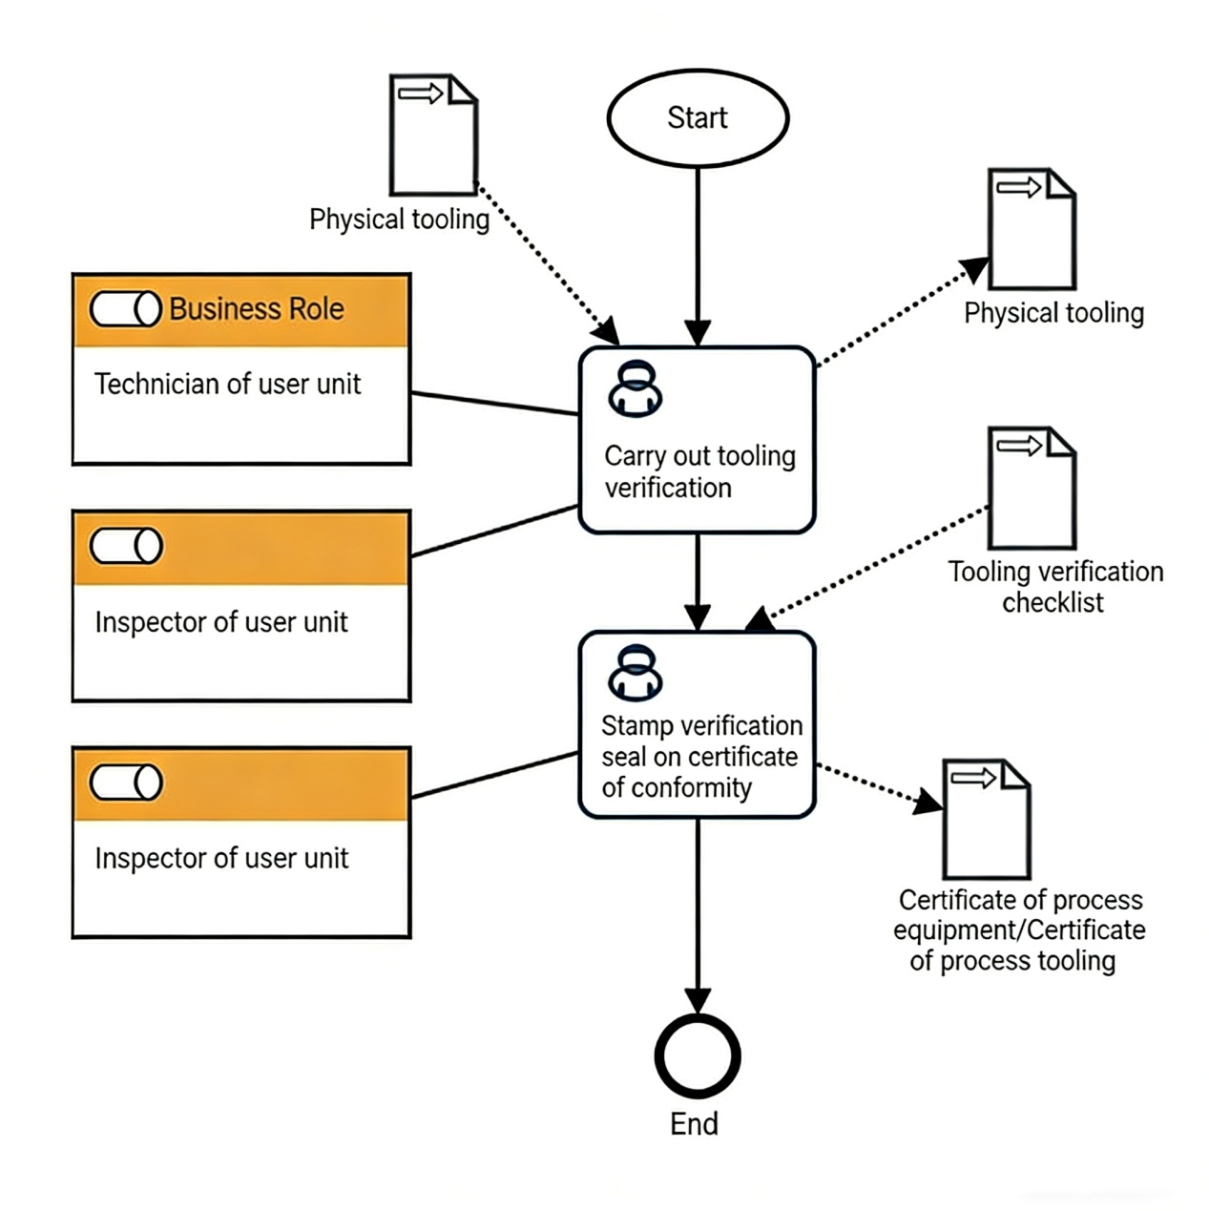

7.1.2 Fixture Verification Process Description Table
(1) Carry out tooling verification

open  exhibition  work  pretend  verify  proof | Step Description | Verify that the tooling can meet the product or assembly capabilities, and statistically analyze the performance data of the tooling after it is put into production
 | Activity frequency | 2 weeks
 | Process role | Unit technician position | Position | technician
 | Input Material | Physical tooling | Output Material | Tooling Verification Checklist
 | Compliance Terms | None
 | Standard For Homework Execution | None
 | Risk And Response Measures Available | None

(2) Certificate Verification Seal

combine, synthesize  grid  proof  verify  proof  chapter | Step Description | Stamp the verification seal on the certificate of conformity to prove that this fixture has been completed and verified,
 | Activity frequency | 2 weeks
 | Process role | Unit inspector for use | Position | Inspector
 | Input Material | Tooling Verification Checklist | Output Material | Tooling Qualification Certificate
 | Compliance Terms | None
 | Standard For Homework Execution | None
 | Risk And Response Measures Available | None

8 Process Role Responsibility Table

Role Name | Responsibilities
Technicians in the process equipment room | Organize tooling manufacturing units to upgrade or repair tooling
Use unit tooling inspectors | Fill out the tooling verification checklist, and after passing the verification, fill out the tooling qualification certificate
Using unit technicians | Fill in the product information in the tooling verification checklist
Use unit product inspectors | Verify whether the product characteristics controlled by the tooling are qualified

9 Process Performance Indicator Table

None

10 Establish the following management standards to support this program

None

11 Record Control

The filling and maintenance of relevant records shall be carried out in accordance with the requirements of procedure document GLC231008.

